**3.2 First running the program**

The program starts in Figure 3.2. First, admin must login on login frame. It is needed to enter the Username and Password and click the “Login” button.

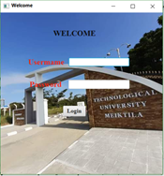

Figure 3.2. Admin Login Form

**3.3. Displaying Major Form**

If login is successful, the admin reach major frame that shown in Figure 3.3. The admin can choose any major on the major frame for select that desired year.

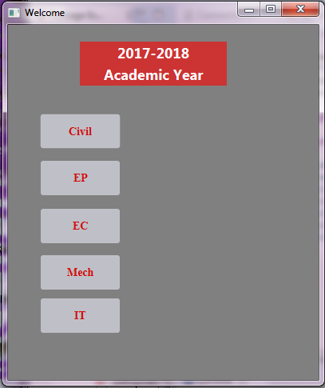

Figure 3.3. Major Form

**3.4. Displaying Years of Major Form**

For example, if admin choose the major, Civil, this application shows six years of civil major shown in Figure 3.4.

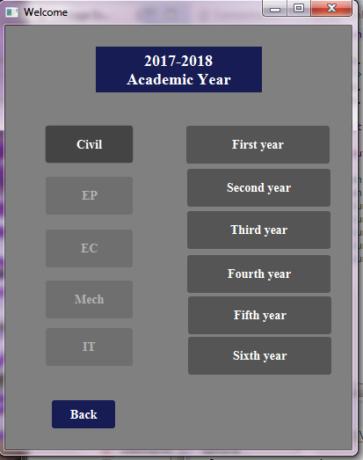

Figure 3.4. Six years of Major form

**3.5. Displaying Student Marks Table**

If the admin click the first year button, shows the student marks table shown in Figure 3.5.

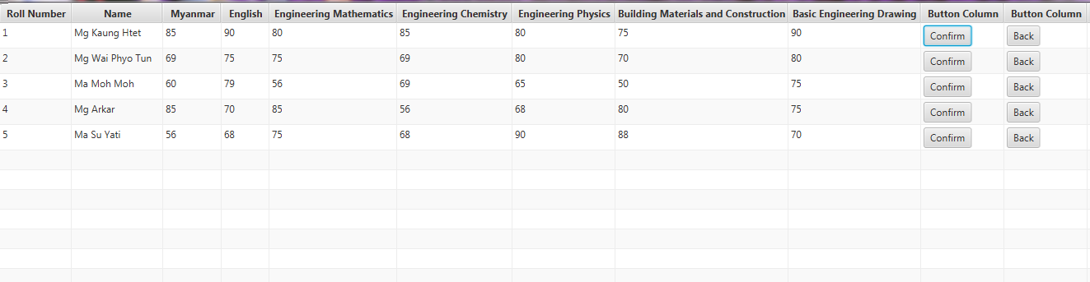

Figure 3.5. Student marks table

**3.6. Displaying Student Exam Marksheet**

If the admin click the confirm button, shows the student marksheet. If the admin click the back button, return the six years of the major page.

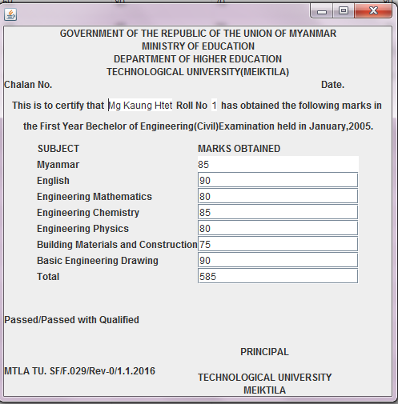

Figure 3.6. Student exam marksheet